7.76: The kinetic energy 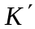 after moving up the ramp the distance s will be the energy initially stored in the spring, plus the (negative) work done by gravity and friction, or
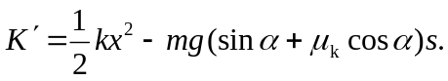

Minimizing the speed is equivalent to minimizing , and differentiating the above expression with respect to and setting 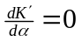 gives
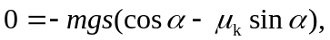
or 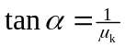, 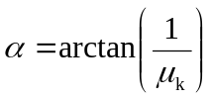. Pushing the box straight up 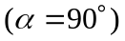 maximizes the vertical displacement h, but not 

